Project Report
Streamlining IT Procurement: Automating Standard Laptop Orders with Flow Designer
Team ID | Team 7
Team Members | Haresh S (Team Leader), Gobika M, Hariharan M, Harini G
Platform | ServiceNow (Flow Designer)
Date | 4 October 2026

Contents
1. INTRODUCTION
1.1 Project Overview
1.2 Purpose
2. IDEATION PHASE
2.1 Problem Statement
2.2 Empathy Map Canvas
2.3 Brainstorming
3. REQUIREMENT ANALYSIS
3.1 Customer Journey map
3.2 Solution Requirement
3.3 Data Flow Diagram
3.4 Technology Stack
4. PROJECT DESIGN
4.1 Problem Solution Fit
4.2 Proposed Solution
4.3 Solution Architecture
5. PROJECT PLANNING & SCHEDULING
5.1 Project Planning
6. FUNCTIONAL AND PERFORMANCE TESTING
6.1 Performance Testing
7. RESULTS
7.1 Output Screenshots
8. ADVANTAGES & DISADVANTAGES
9. CONCLUSION
10. FUTURE SCOPE
11. APPENDIX
Source Code (if any)
Dataset Link
GitHub & Project Demo Link

1. INTRODUCTION

1.1 Project Overview
Streamlining IT Procurement: Automating Standard Laptop Orders with Flow Designer is a ServiceNow project that automates the step between the approval of a standard laptop request and the configuration of that laptop.
Employees order a Standard Laptop from Service Catalog > Hardware > Order Now. Once the request is approved, the Flow Designer flow "Standard laptop tasks" (Application: Global, Run user: System user, Service Catalog trigger) creates a Catalog Task from the Requested Item record. The task carries the short description and description "Laptop need to Configured", the Assignment group Hardware and the Approval value Approved. The flow is attached to the Standard Laptop catalog item through Maintain Items > Process engine, so every order follows the same path.
The solution is built on the ServiceNow low-code platform. It runs entirely on the ServiceNow cloud instance and uses no external API and no machine learning model.

1.2 Purpose
The purpose of the project is to make IT procurement for standard laptops efficient and consistent by replacing a manual hand-off with automation. The project aims to:
- Reduce manual intervention and the chance of errors in laptop procurement.
- Make sure standard laptops are configured promptly upon arrival, so users wait less.
- Improve the use of IT department resources by allocating configuration tasks automatically to the Hardware team.
- Raise the overall efficiency and productivity of IT procurement operations.

2. IDEATION PHASE

2.1 Problem Statement
The IT procurement process lacks efficiency and automation. For standard laptop orders, the configuration step that follows an approved request is prone to oversight or delay. The configuration task has to be created and assigned by hand, which adds manual overhead, frustrates users who are waiting for their laptops, and uses IT department resources inefficiently.
The team framed the problem in the brainstorming session as a How Might We statement:
How might we automate standard laptop orders in ServiceNow Flow Designer, so configuration tasks are created and assigned to the Hardware team automatically after approval, reducing delays and manual effort?

2.2 Empathy Map Canvas
The empathy map captures how an IT procurement team member experiences the current manual process: what the person thinks and feels, hears, sees, says and does, along with the pains and gains of the process.
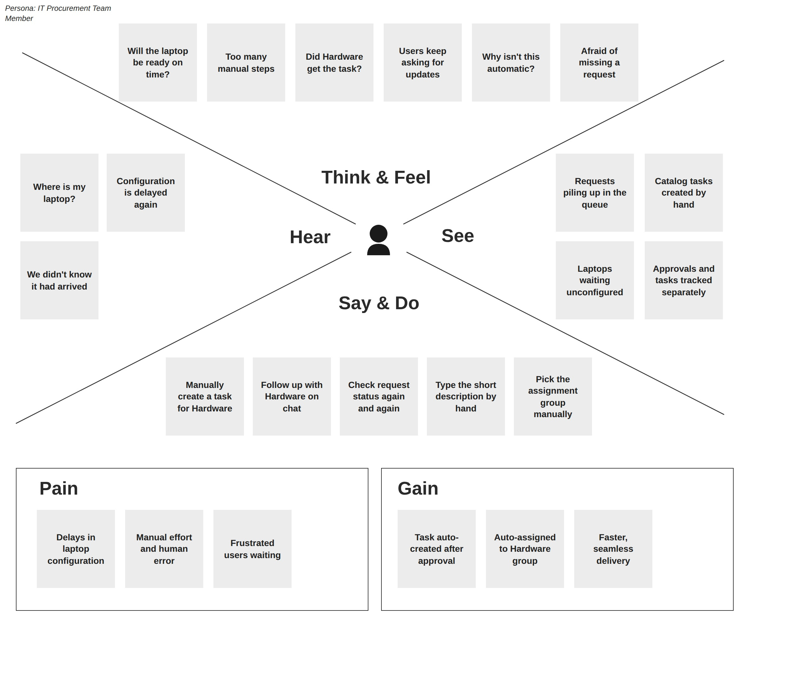
Figure 2.1: Empathy map for the IT procurement team member (Team 7)
Quadrant | Key points
Think & Feel | Will the laptop be ready on time?  Too many manual steps  Did Hardware get the task?  Users keep asking for updates  Why isn't this automatic?  Afraid of missing a request
Hear | Where is my laptop?  Configuration is delayed again  We didn't know it had arrived
See | Requests piling up in the queue  Catalog tasks created by hand  Laptops waiting unconfigured  Approvals and tasks tracked separately
Say & Do | Manually create a task for Hardware  Follow up with Hardware on chat  Check request status again and again  Type the short description by hand  Pick the assignment group manually
Pain | Delays in laptop configuration  Manual effort and human error  Frustrated users waiting
Gain | Task auto-created after approval  Auto-assigned to Hardware group  Faster, seamless delivery

2.3 Brainstorming
The team (Haresh S, Gobika M, Hariharan M and Harini G) held a brainstorming and idea prioritization session using the Mural template. Each member listed ideas individually, the ideas were grouped into four clusters, and the ideas were then placed on an importance versus feasibility grid.
- Trigger & approval: Service Catalog trigger, start the flow only after approval, run the flow as System user.
- Create & route task: Create Catalog Task from the Requested Item, set the short description "Laptop need to Configured", set Approval to Approved, assign the task to the Hardware group.
- Link & verify: attach the flow to the Standard Laptop item through Maintain Items > Process engine, then confirm the Hardware team sees the task.
- Future improvements: email the user when the laptop is ready, escalate if a task sits idle, Slack alert to the Hardware team, a turnaround-time dashboard, auto-approval of low-cost standard laptops, and auto-reorder when stock is low.
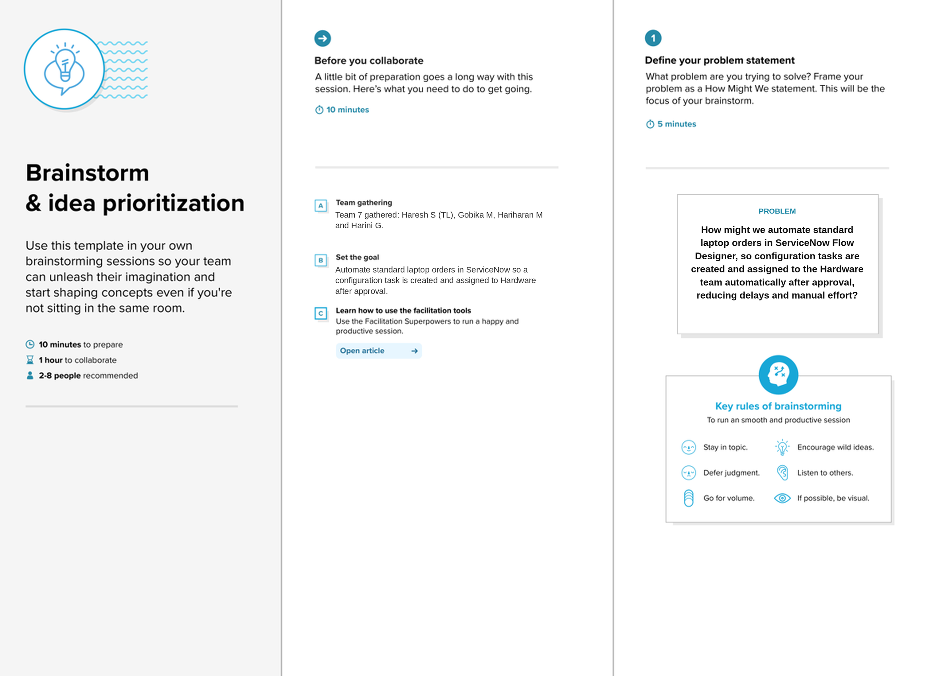
Figure 2.2: Step 1 - Team gathering, collaboration and selecting the problem statement
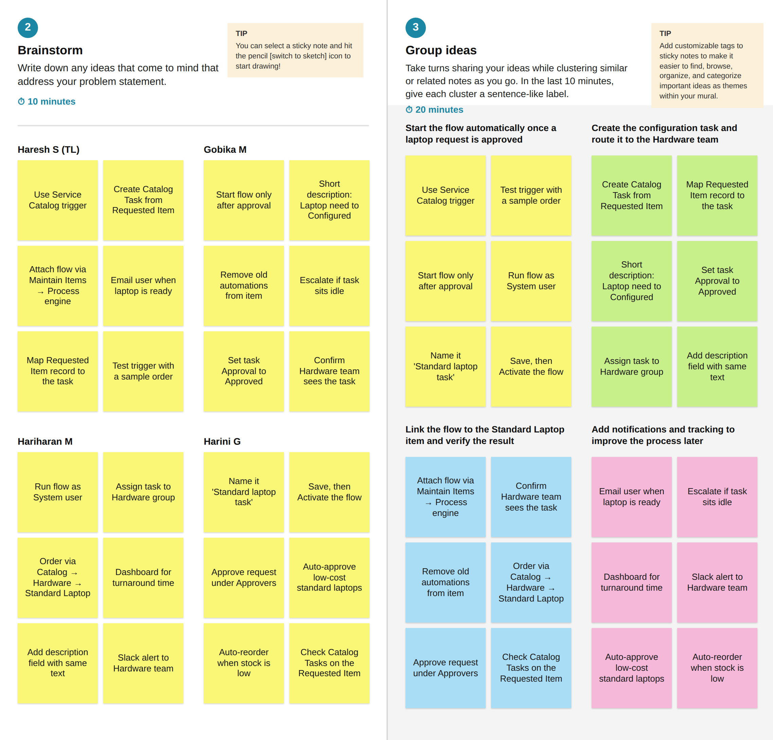
Figure 2.3: Step 2 - Brainstorm, idea listing and grouping
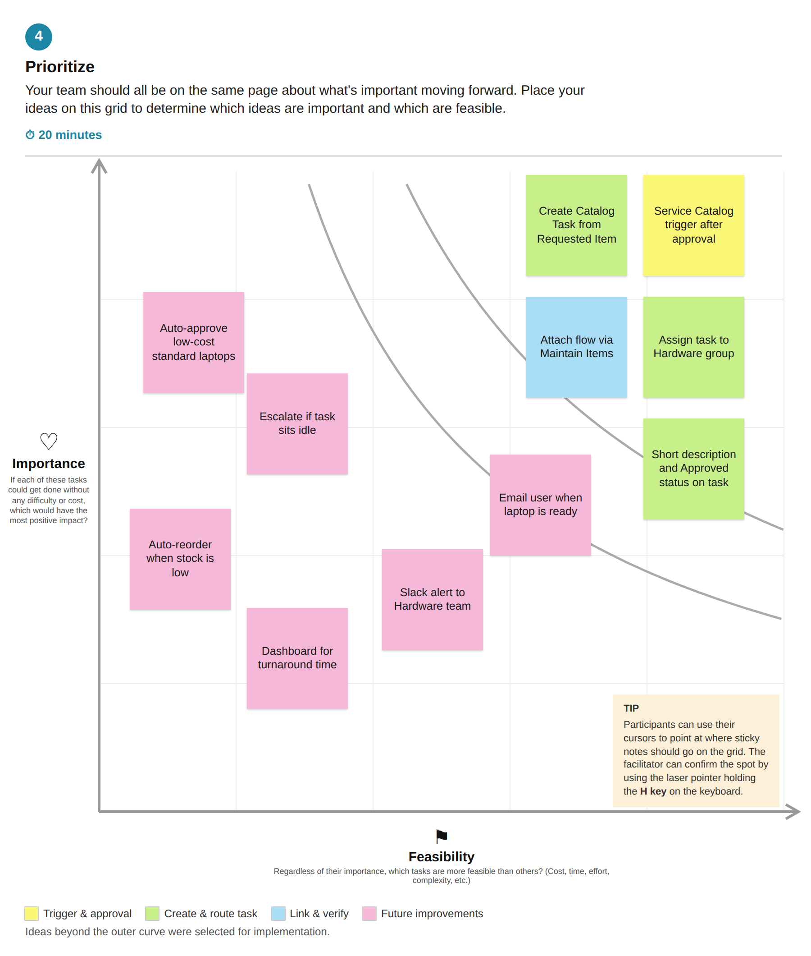
Figure 2.4: Step 3 - Idea prioritization (importance versus feasibility)

3. REQUIREMENT ANALYSIS

3.1 Customer Journey map
The journey map follows the employee who requests a standard laptop through the five stages Entice, Enter, Engage, Exit and Extend. The empathy map in section 2.2 looks at the same process from the IT procurement team's side. Solid notes come from the project document; dashed notes marked H are hypotheses to be validated with real users, because no customer interviews were conducted.
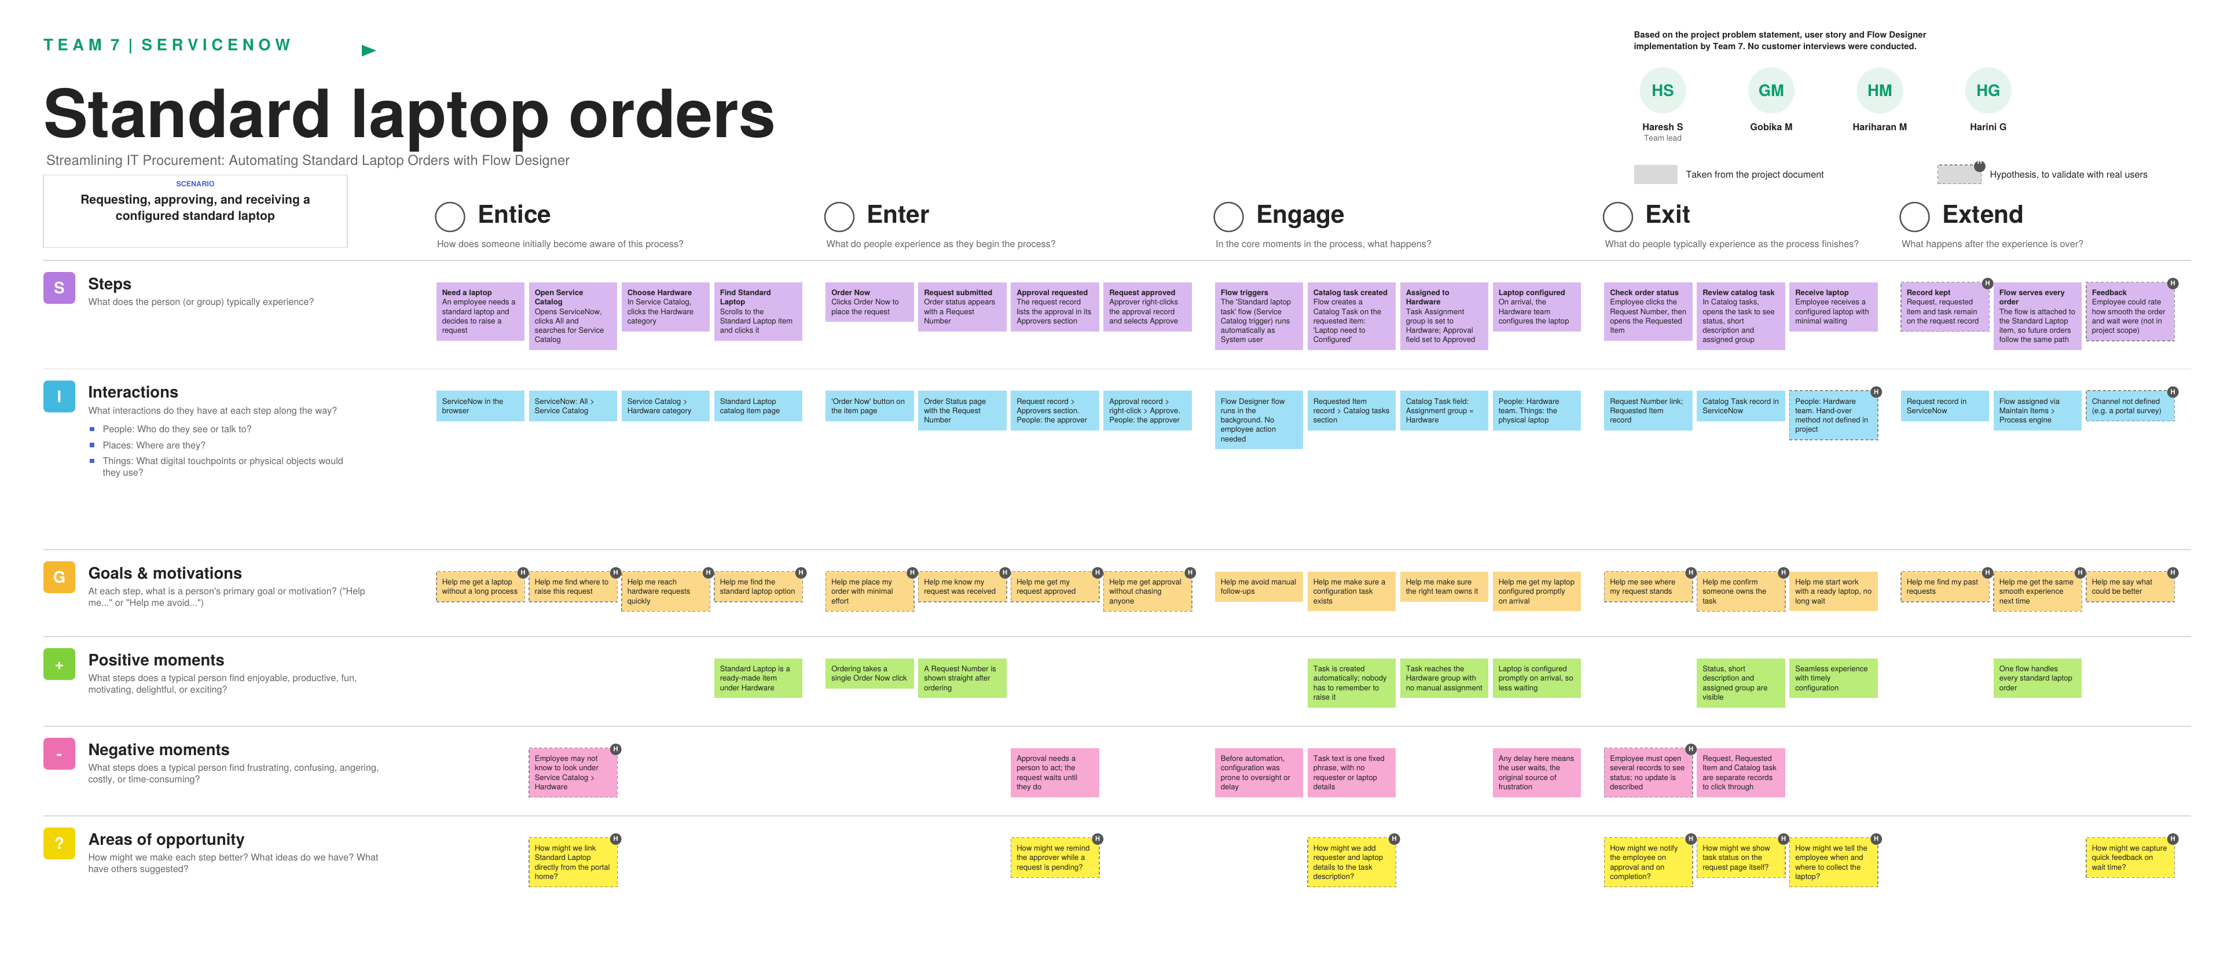
Figure 3.1: Customer journey map - standard laptop orders (full-size PDF supplied with this report)

3.2 Solution Requirement
Functional requirements:
FR No. | Functional Requirement (Epic) | Sub Requirement (Story / Sub-Task)
FR-1 | Service Catalog Ordering | Browse Service Catalog > Hardware  Select the Standard Laptop item  Place the request through Order Now  View order status and Request Number
FR-2 | Request Approval | Approver opens the request and its Approvers section  Approver approves the request
FR-3 | Flow Creation (Flow Designer) | Create flow "Standard laptop tasks" (Global application, Run user: System user)  Add Service Catalog trigger  Add Create Catalog Task action using the Requested Item record
FR-4 | Task Configuration and Assignment | Set short description and description to "Laptop need to Configured"  Set Assignment group to Hardware  Set Approval to Approved  Save and activate the flow
FR-5 | Flow Assignment to Catalog Item | Open Maintain Items and select Standard Laptop  In Process engine, remove other automations and add the "Standard laptop tasks" flow  Save the record
FR-6 | Request and Task Tracking | Open the Requested Item from the Request Number  Open the Catalog tasks section to view the generated task  Verify status, short description and assigned group (Hardware)

Non-functional requirements:
NFR No. | Non-Functional Requirement | Description
NFR-1 | Usability | Employees order through one Standard Laptop item (Service Catalog > Hardware > Order Now) and track progress through the Request Number, Requested Item and Catalog task records. No manual task creation is needed.
NFR-2 | Security | The flow runs as System user, and the catalog task is generated only after the request is approved. Access follows ServiceNow's standard login and role-based permissions.
NFR-3 | Reliability | The flow is saved, activated and attached to the Standard Laptop item, so every approved order produces a catalog task with the same short description and Hardware assignment group, removing the oversight-prone manual step.
NFR-4 | Performance | The catalog task is created automatically on approval, so configuration work reaches the Hardware team without manual hand-off and user wait time is reduced. No numeric response targets are defined in the project.
NFR-5 | Availability | The solution runs on the ServiceNow instance through Flow Designer, with no separate infrastructure. Availability follows the instance; no separate availability target is defined.
NFR-6 | Scalability | One flow attached to the catalog item handles all standard laptop orders, and each request gets its own catalog task. The same pattern can be reused for other standard hardware items.

3.3 Data Flow Diagram
The context diagram (Level 0) shows the system as one process exchanging data with the requester, the approver and the Hardware team. Level 1 breaks it into four processes: place the order, approve the request, trigger the flow, and create the catalog task. It also shows the three data stores used: Requests / RITM, Approvals and Catalog Tasks.
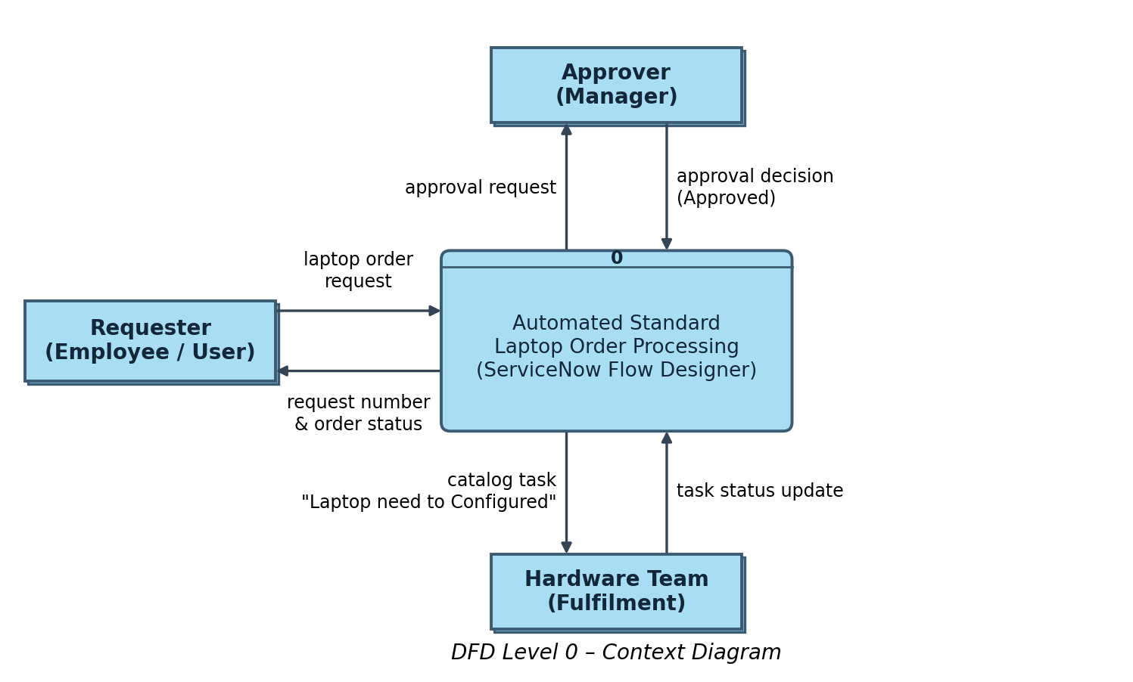
Figure 3.2: DFD Level 0 - Context diagram
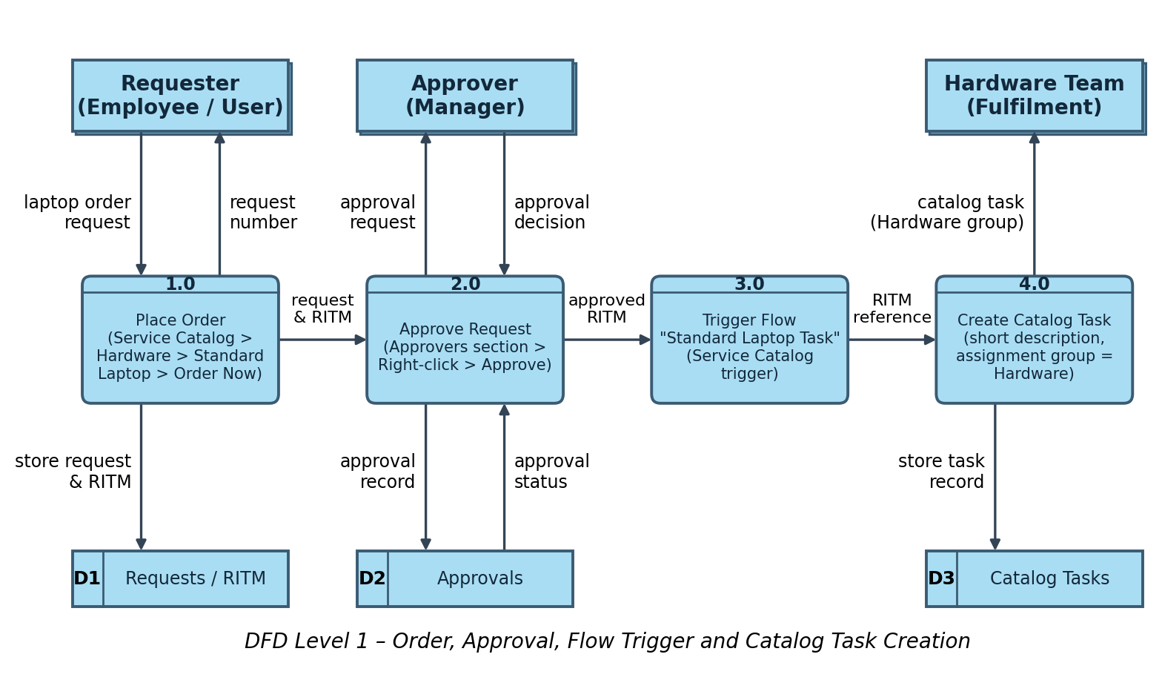
Figure 3.3: DFD Level 1 - Order, approval, flow trigger and catalog task creation
User stories:
User Type | Functional Requirement (Epic) | USN | User Story / Task | Acceptance criteria | Priority | Release
Requester (Employee) | Order Standard Laptop | USN-1 | As a requester, I can open the Service Catalog, go to Hardware, select "Standard Laptop" and click "Order Now" to place a laptop request. | A request is created and its Request Number is displayed in the order status | High | Sprint-1
 |  | USN-2 | As a requester, I can open my Request Number to track the status of my laptop order. | I can open the request record and see the approval and requested item details | Medium | Sprint-2
Approver (Manager) | Approval | USN-3 | As an approver, I can see the pending approval in the Approvers section of the request record. | The approval record is listed with its state as Requested | High | Sprint-2
 |  | USN-4 | As an approver, I can approve the laptop request by right-clicking the approval record and selecting Approve. | Approval state changes to Approved and the requested item moves ahead for fulfilment | High | Sprint-2
IT Procurement Team (Flow Administrator) | Flow Creation | USN-5 | As an administrator, I can create a flow named "Standard laptop tasks" in Flow Designer (Application: Global, Run as: System user). | The flow is created and saved under Flow Designer | High | Sprint-1
 |  | USN-6 | As an administrator, I can add a Service Catalog trigger to the flow so that it starts whenever a standard laptop is requested. | The flow triggers automatically when the catalog item is ordered | High | Sprint-1
 | Catalog Task Automation | USN-7 | As an administrator, I can add the "Create Catalog Task" action with the Requested Item record, short description "Laptop need to Configured", Assignment group "Hardware" and Approval "Approved". | A catalog task is created automatically with the correct short description and assignment group | High | Sprint-1
 |  | USN-8 | As an administrator, I can save and activate the flow. | The flow status shows Active | High | Sprint-1
 | Flow Assignment | USN-9 | As an administrator, I can attach the "Standard laptop tasks" flow to the Standard Laptop catalog item under Maintain Items > Process Engine, removing other automations. | The Standard Laptop item runs only the assigned flow when ordered | High | Sprint-2
Hardware Team Member | Laptop Configuration | USN-10 | As a hardware team member, I receive the catalog task automatically in the Hardware assignment group, so the laptop can be configured promptly on arrival. | The catalog task appears under Catalog Tasks of the requested item with the short description and Hardware assignment group | High | Sprint-3
 |  | USN-11 | As a hardware team member, I can open the catalog task and view its updated status to confirm the laptop configuration. | The catalog task record shows the updated status and assigned group | Medium | Sprint-3

3.4 Technology Stack
The architecture is a ServiceNow-only solution: the user interface, application logic, database and infrastructure are all provided by the ServiceNow cloud platform.
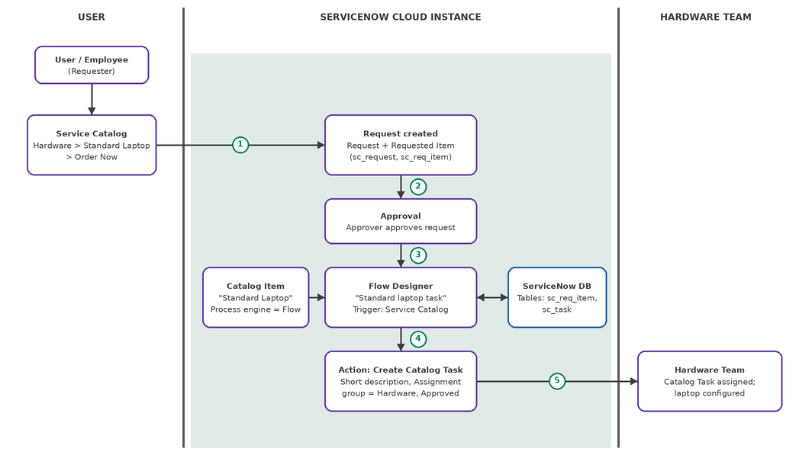
Figure 3.4: Technical architecture - automated standard laptop order processing using ServiceNow Flow Designer
Table 1: Components & technologies
S.No | Component | Description | Technology
1 | User Interface | Employees order a Standard Laptop from the Service Catalog (Hardware > Standard Laptop > Order Now) and track the Request; approvers and the hardware team work through the ServiceNow web interface. | ServiceNow Service Catalog / Service Portal (platform-provided HTML, CSS, JavaScript)
2 | Application Logic-1 | Flow Designer flow "Standard laptop tasks" (Application: Global, Run as: System user) starts through the Service Catalog trigger once the request is approved. | ServiceNow Flow Designer (Trigger: Service Catalog)
3 | Application Logic-2 | Flow assignment: the flow is attached to the "Standard Laptop" catalog item (Maintain Items > Process engine) so every order runs the automation. | ServiceNow Maintain Items / Process Engine
4 | Application Logic-3 | Create Catalog Task action: uses the Requested Item record to create a task with short description "Laptop need to Configured" and Assignment group "Hardware". | Flow Designer Action: Create Catalog Task (Assignment group = Hardware)
5 | Database | Request, Requested Item, Approval and Catalog Task records with their field values (short description, description, assignment group, approval). | ServiceNow platform tables (sc_request, sc_req_item, sc_task)
6 | Cloud Database | Database hosted and managed on the ServiceNow cloud instance; no separate database service is used. | ServiceNow cloud instance database
7 | File Storage | No separate file storage required; any attachment on a request is kept in the platform attachment store. | ServiceNow Attachments (platform storage)
8 | External API-1 | Not applicable: no external API is used; the entire process runs inside ServiceNow. | Not applicable
9 | External API-2 | Not applicable: no second external API is used. | Not applicable
10 | Machine Learning Model | Not applicable: no machine learning model is used; the process is rule-based automation. | Not applicable
11 | Infrastructure (Server / Cloud) | Application deployment on Cloud (SaaS / PaaS) Local Server Configuration: Not applicable (no local server) Cloud Server Configuration: ServiceNow cloud instance accessed through a web browser | ServiceNow Cloud

Table 2: Application characteristics
S.No | Characteristics | Description | Technology
1 | Open-Source Frameworks | No separate open-source framework is added; the solution is built on the ServiceNow low-code platform using Flow Designer. | ServiceNow Flow Designer (low-code)
2 | Security Implementations | Access is controlled through user login and roles for requester, approver and hardware team; the flow runs as System user; the instance is accessed over HTTPS. | ServiceNow roles and ACLs, user authentication, HTTPS (TLS)
3 | Scalable Architecture | The platform follows a multi-tier design (presentation, application, database); new orders run the same flow without code changes, so volume can grow. | ServiceNow multi-tier cloud platform, Flow Designer
4 | Availability | The application is hosted on the managed ServiceNow cloud, which provides platform-level redundancy and failover. | ServiceNow managed cloud infrastructure
5 | Performance | Catalog task creation is event-driven and automatic, removing manual steps and delays between approval and configuration. | Flow Designer event-driven execution

4. PROJECT DESIGN

4.1 Problem Solution Fit
The Problem-Solution Fit canvas checks that the solution matches the customer segments, their constraints, behaviour, triggers and emotions. Italic grey text marks hypotheses that are not stated in the project document.
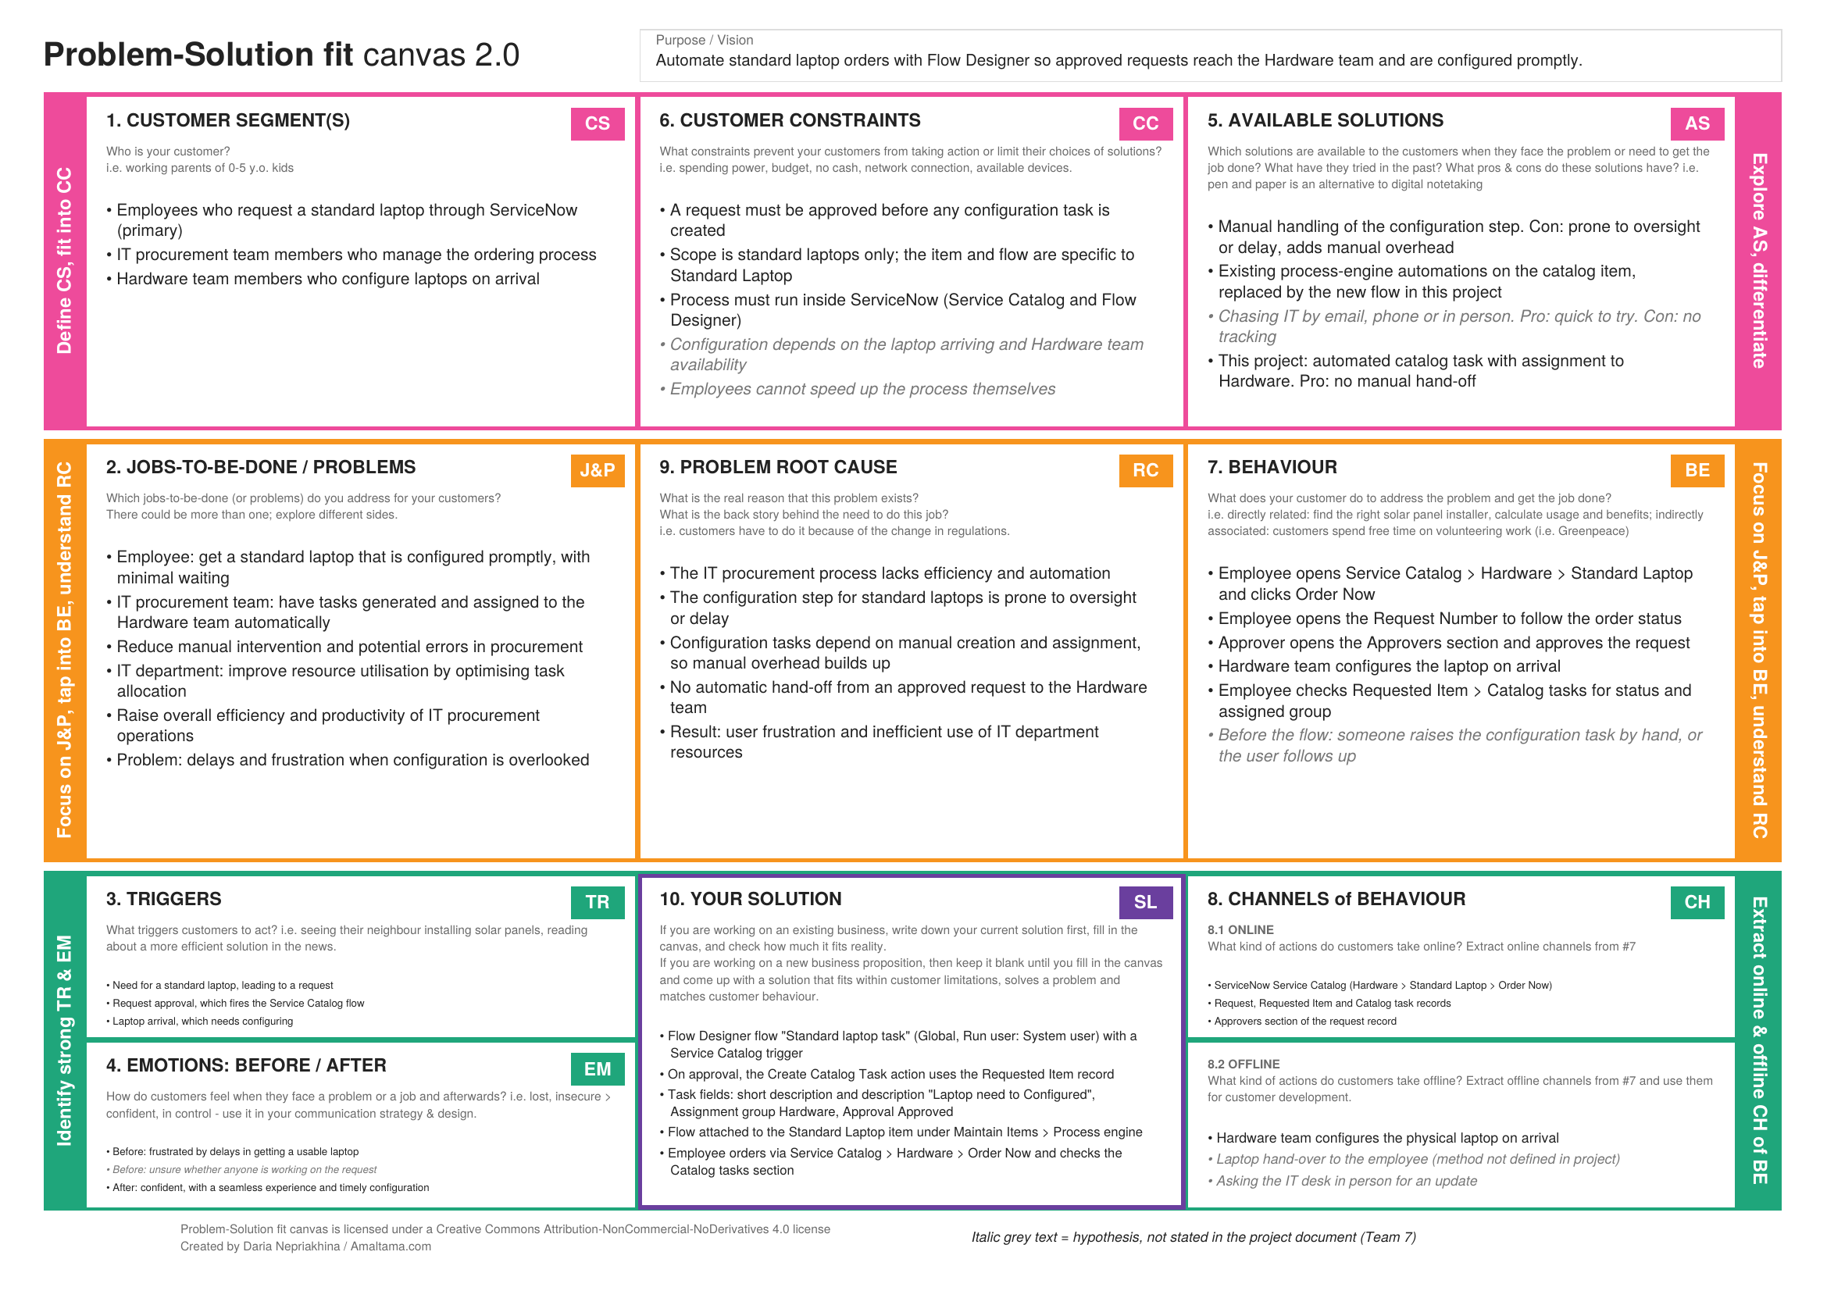
Figure 4.1: Problem-Solution Fit canvas (Team 7)

4.2 Proposed Solution
S.No. | Parameter | Description
1 | Problem Statement (Problem to be solved) | The IT procurement process lacks efficiency and automation, causing delays and manual overhead, particularly for standard laptop orders. The configuration step after a request is prone to oversight or delay, which frustrates users and leads to inefficient use of IT department resources.
2 | Idea / Solution description | Use ServiceNow Flow Designer to create the flow "Standard laptop tasks" with a Service Catalog trigger. Once a Standard Laptop request is approved, the flow automatically creates a Catalog Task from the Requested Item, with the short description "Laptop need to Configured" and the Assignment group set to Hardware. The flow is attached to the Standard Laptop catalog item through Maintain Items > Process engine. Employees order through Service Catalog > Hardware > Order Now, and the Hardware team receives the configuration task without manual intervention.
3 | Novelty / Uniqueness | The solution builds the hand-off from approval to configuration into the request itself, so tasks are generated and assigned to the Hardware team automatically instead of relying on someone to remember. It uses only ServiceNow's built-in Flow Designer, with no custom code or extra tools.
4 | Social Impact / Customer Satisfaction | Users get a seamless experience: laptops are configured promptly on arrival, which reduces waiting time and frustration. The IT team has fewer manual steps and fewer errors, and the Hardware team gets clear, assigned tasks. No satisfaction survey has been run, so these benefits are expected outcomes, not measured results.
5 | Business Model (Revenue Model) | This is an internal IT efficiency project, so it has no direct revenue model. The value is operational: less manual effort, better use of IT department resources, and higher productivity in procurement. No cost-saving figures have been calculated.
6 | Scalability of the Solution | One flow attached to the Standard Laptop catalog item handles every standard laptop order, and each request creates its own catalog task. The same approach can be reused for other standard hardware items by creating a similar flow and attaching it to those catalog items.

4.3 Solution Architecture
The solution architecture bridges the business problem (delayed, manual laptop configuration) and the technology solution (an automated ServiceNow flow). The figure shows the user, the ServiceNow cloud instance and the Hardware team.
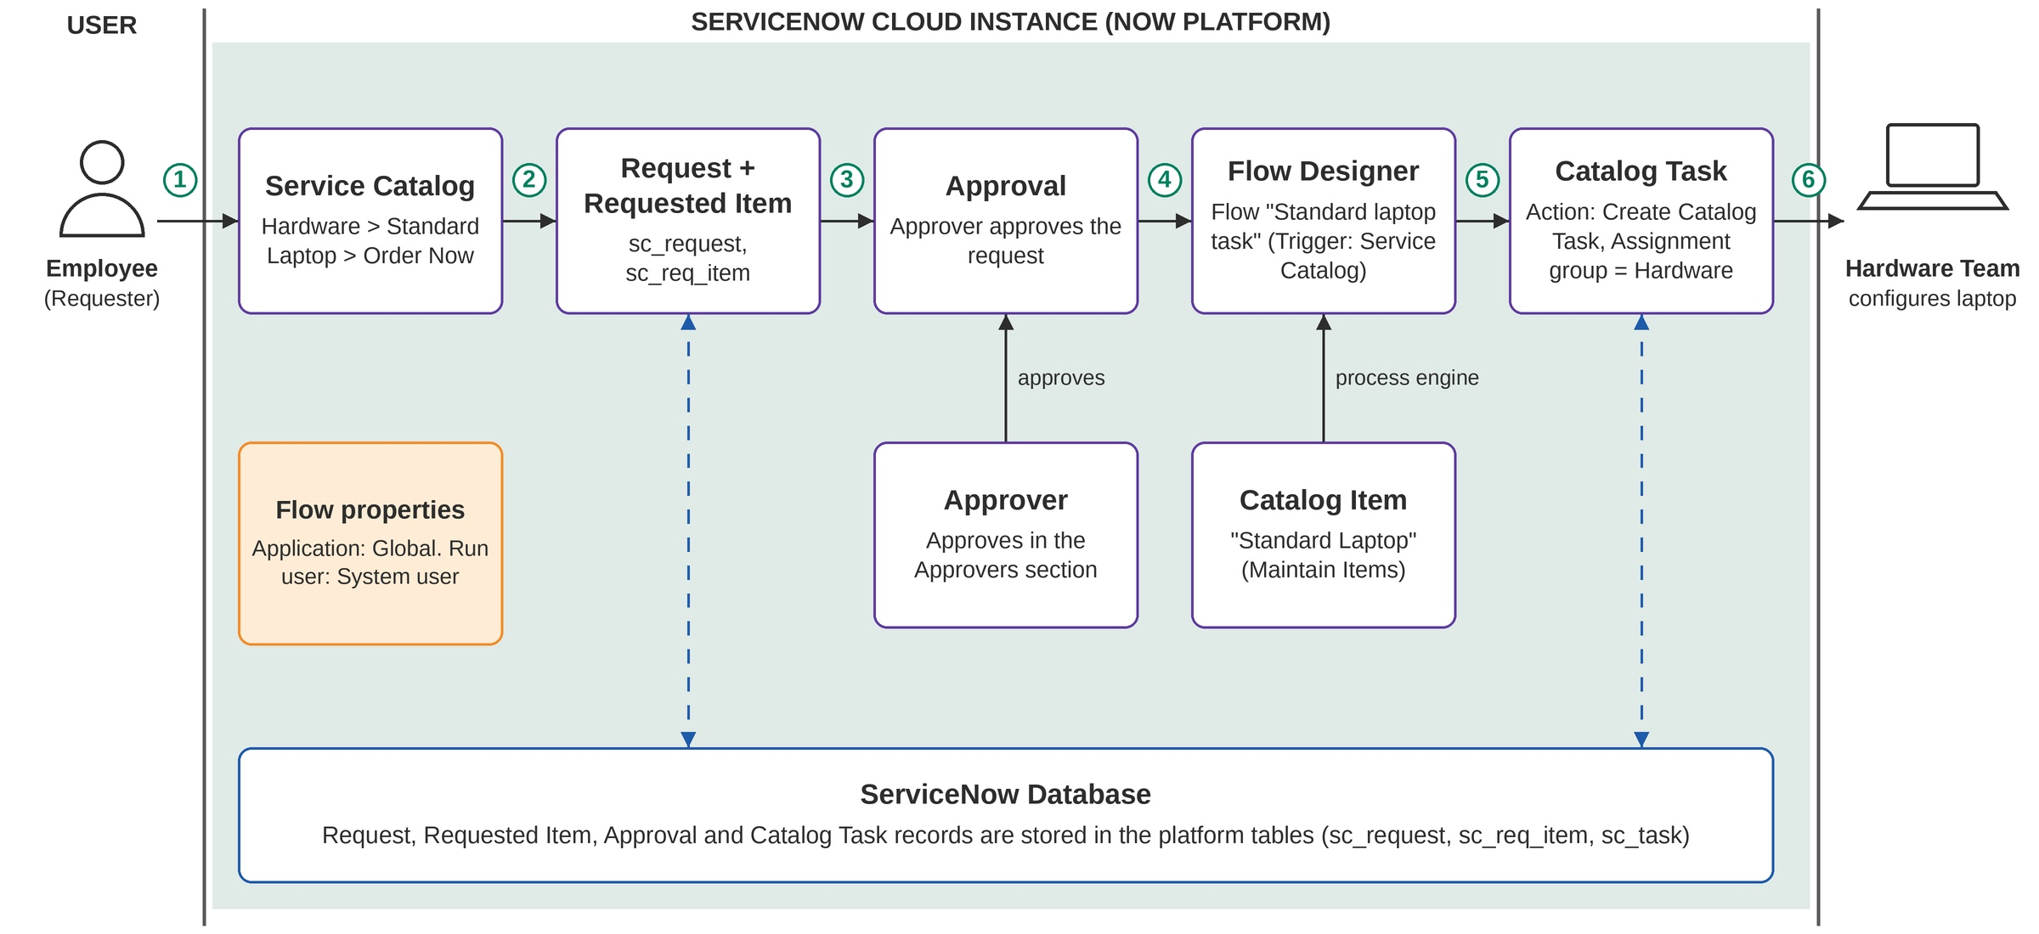
Figure 4.2: Architecture and data flow of the automated standard laptop order process
Flow of data, as numbered in the figure:
- The employee opens Service Catalog > Hardware > Standard Laptop and clicks Order Now.
- The request and the Requested Item are created (tables sc_request and sc_req_item).
- The approver approves the request from the Approvers section.
- The Flow Designer flow "Standard laptop tasks" (Trigger: Service Catalog) runs, because it is attached to the Standard Laptop catalog item through the Process engine.
- The Create Catalog Task action creates the task with the short description, Assignment group = Hardware and Approval = Approved.
- The Hardware team receives the catalog task and configures the laptop.
All records are stored in the ServiceNow platform tables (sc_request, sc_req_item, sc_task). The flow properties are Application: Global and Run user: System user.

5. PROJECT PLANNING & SCHEDULING

5.1 Project Planning
The work is planned as 22 user stories across four sprints of six days each. Each sprint carries 20 story points.
Product backlog and sprint schedule:
Sprint | Functional Requirement (Epic) | USN | User Story / Task | Story Points | Priority | Team Member
Sprint-1 | Flow Creation | USN-1 | As an IT admin, I can open Flow Designer from Process Automation and create a new flow named "Standard laptop tasks" (Application: Global, Run user: System user). | 3 | High | Haresh S
Sprint-1 |  | USN-2 | As an IT admin, I can add the Service Catalog trigger to the flow so that it starts when a laptop request is placed. | 3 | High | Gobika M
Sprint-1 |  | USN-3 | As an IT admin, I can add the Create Catalog Task action and drag the Requested Item record into it so that a catalog task is created for every laptop request. | 5 | High | Hariharan M
Sprint-1 |  | USN-4 | As an IT admin, I can set the short description and description of the catalog task to "Laptop need to Configured" so that the hardware team knows what to do. | 3 | High | Harini G
Sprint-1 |  | USN-5 | As an IT admin, I can set the Assignment group to "Hardware" and Approval to "Approved" on the catalog task so that it reaches the right team. | 3 | High | Haresh S
Sprint-1 |  | USN-6 | As an IT admin, I can save and activate the flow so that it is ready to use. | 3 | High | Gobika M
Sprint-2 | Flow Assignment | USN-7 | As an IT admin, I can open Maintain Items and find the "Standard Laptop" catalog item. | 3 | High | Hariharan M
Sprint-2 |  | USN-8 | As an IT admin, I can open the Process engine tab of the catalog item and remove the existing automations. | 3 | Medium | Harini G
Sprint-2 |  | USN-9 | As an IT admin, I can add the "Standard laptop tasks" flow to the catalog item so that it runs for every laptop order. | 5 | High | Haresh S
Sprint-2 |  | USN-10 | As an IT admin, I can save the catalog item record so that the flow assignment is stored. | 2 | High | Gobika M
Sprint-2 | Service Catalog Ordering | USN-11 | As an employee, I can open Service Catalog > Hardware and find the "Standard Laptop" item. | 3 | High | Hariharan M
Sprint-2 |  | USN-12 | As an employee, I can click Order Now to place a request for a standard laptop. | 4 | High | Harini G
Sprint-3 | Approval and Task Generation | USN-13 | As an employee, I can see the order status and open the Request Number record after placing the order. | 3 | High | Gobika M
Sprint-3 |  | USN-14 | As an approver, I can approve the request from the Approvers section of the request record. | 5 | High | Haresh S
Sprint-3 |  | USN-15 | As a hardware team member, I can see a catalog task generated automatically in the Catalog tasks section of the Requested Item once the request is approved. | 5 | High | Hariharan M
Sprint-3 |  | USN-16 | As a hardware team member, I can see the short description "Laptop need to Configured" and the Hardware assignment group on the task so that I can configure the laptop promptly. | 4 | High | Harini G
Sprint-3 |  | USN-17 | As an IT procurement team member, I can confirm that the task is created without any manual intervention. | 3 | Medium | Gobika M
Sprint-4 | Testing and Documentation | USN-18 | As a tester, I can place a test order, approve it and verify that the catalog task is created end to end. | 5 | High | Harini G
Sprint-4 |  | USN-19 | As an IT admin, I can check the Flow Designer execution details to confirm that each run completed without errors. | 3 | Medium | Hariharan M
Sprint-4 |  | USN-20 | As a team member, I can fix any issues found during testing so that the flow works as expected. | 3 | Medium | Haresh S
Sprint-4 |  | USN-21 | As a team member, I can prepare the project documentation (design phase documents and project report). | 5 | Medium | Gobika M
Sprint-4 |  | USN-22 | As a stakeholder, I can see a final demo of the automated laptop order flow. | 4 | Low | Haresh S

Project tracker:
Sprint | Total Story Points | Duration | Sprint Start Date | Sprint End Date (Planned) | Story Points Completed (as on Planned End Date) | Sprint Release Date (Actual)
Sprint-1 | 20 | 6 Days | 05 Oct 2026 | 10 Oct 2026
Sprint-2 | 20 | 6 Days | 12 Oct 2026 | 17 Oct 2026
Sprint-3 | 20 | 6 Days | 19 Oct 2026 | 24 Oct 2026
Sprint-4 | 20 | 6 Days | 26 Oct 2026 | 31 Oct 2026

The Story Points Completed and Sprint Release Date (Actual) columns stay blank until each sprint finishes.
Velocity:
With a 6-day sprint and a team velocity of 20 story points per sprint, the average velocity per day is AV = velocity / sprint duration = 20 / 6 ≈ 3.33 story points per day.
Burndown chart:
To be added once sprint progress data is available (actual story points completed per day).

6. FUNCTIONAL AND PERFORMANCE TESTING

6.1 Performance Testing
Testing follows the User Acceptance Testing (UAT) test cases below. They cover the catalog item, ordering, approval, automatic task creation, task fields and flow assignment, together with two negative cases. Results come from one end-to-end run on the instance (request REQ0010003, with the System Administrator account as requester and Eric Schroeder as approver). Test cases without screenshot evidence are marked as not tested. An end-to-end test and a check of the Flow Designer execution details are still planned for Sprint-4.
Test Case ID | Test Scenario | Test Steps | Expected Result | Actual Result | Pass/Fail
TC-001 | Standard Laptop item is available in the catalog | Click All and search for Service Catalog  Open Service Catalog and click Hardware  Scroll to Standard Laptop and click it | The Standard Laptop item is listed under Hardware and opens with an Order Now button. | Standard Laptop listed under Hardware (Fig. 7.1) | Pass
TC-002 | Place a standard laptop order | Open the Standard Laptop item  Click Order Now  Note the order status and Request Number | The request is submitted and the order status shows a Request Number. | Request REQ0010003 created (Fig. 7.3) | Pass
TC-003 | Approve the request | Click the Request Number  Scroll down to the Approvers section  Right-click the approval record and click Approve | The approval record shows Approved. | Approval shows Approved (Fig. 7.5) | Pass
TC-004 | Catalog task is created after approval | Open the Requested Item section of the request  Open the Requested Item record  Scroll to the Catalog tasks section | One catalog task exists for the requested item. | Catalog task SCTASK0010003 under RITM0010003 (Fig. 7.8) | Pass
TC-005 | Task fields are set by the flow | Open the catalog task  Check Short description and Description  Check Assignment group and Approval | Short description and Description are "Laptop need to Configured"; Assignment group is Hardware; Approval is Approved. | Short description and description "Laptop need to Configured"; group Hardware; Approval Approved (Figs. 7.8, 7.9) | Pass
TC-006 | Flow is assigned to the Standard Laptop item | Click All and search for Maintain Items  Open the Standard Laptop record  Check Process engine | Only the "Standard laptop tasks" flow is listed; the other automations are removed. | Process engine shows flow "Standard laptop tasks"; Workflow and Execution Plan empty (Fig. 7.7) | Pass
TC-007 | Negative: no catalog task before approval | Place a new Standard Laptop order  Do not approve the request  Open the Requested Item and check Catalog tasks | No catalog task is created until the request is approved. | Not tested. No evidence yet.
TC-008 | Negative: rejected request creates no task | Place a new Standard Laptop order  In the Approvers section, reject the approval  Open the Requested Item and check Catalog tasks | No catalog task is created for a rejected request. | Not tested. No evidence yet.

Bug tracking: no bugs were observed in the recorded run. TC-007 and TC-008 still need a screenshot of the Requested Item before approval and after rejection.

7. RESULTS

7.1 Output Screenshots
The screenshots below are from the project's ServiceNow instance, for request REQ0010003.
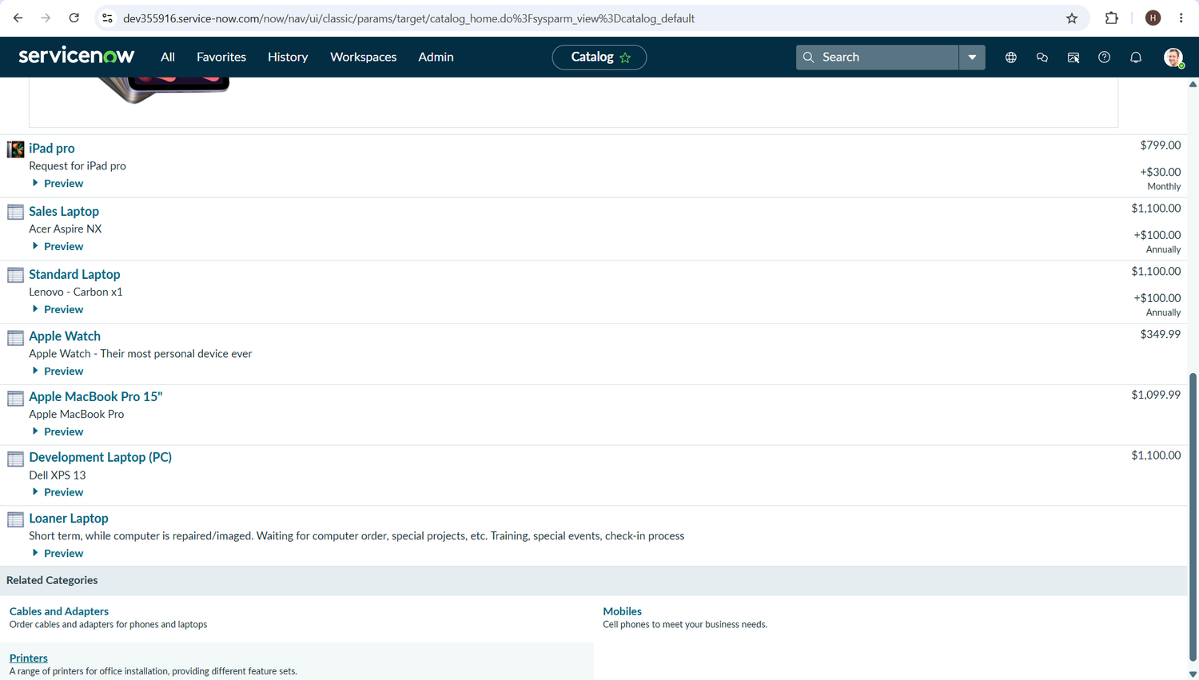
Figure 7.1: Service Catalog > Hardware, listing the Standard Laptop item
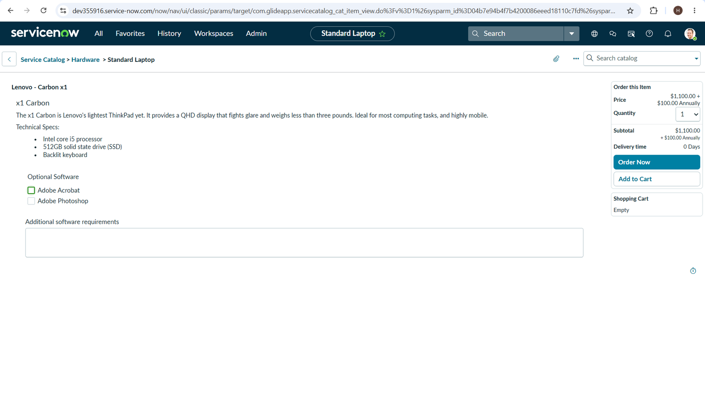
Figure 7.2: Standard Laptop item page with the Order Now button
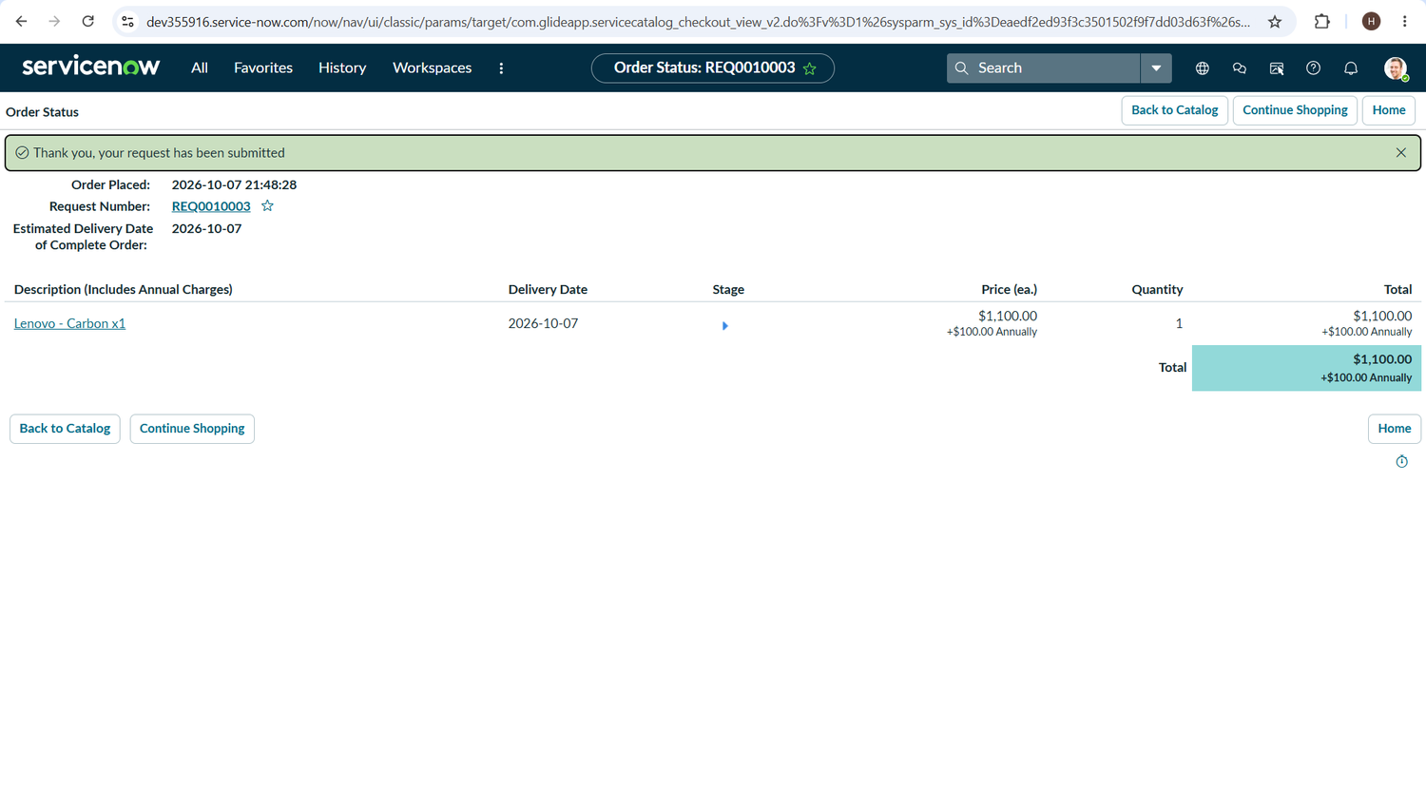
Figure 7.3: Order status page showing Request Number REQ0010003
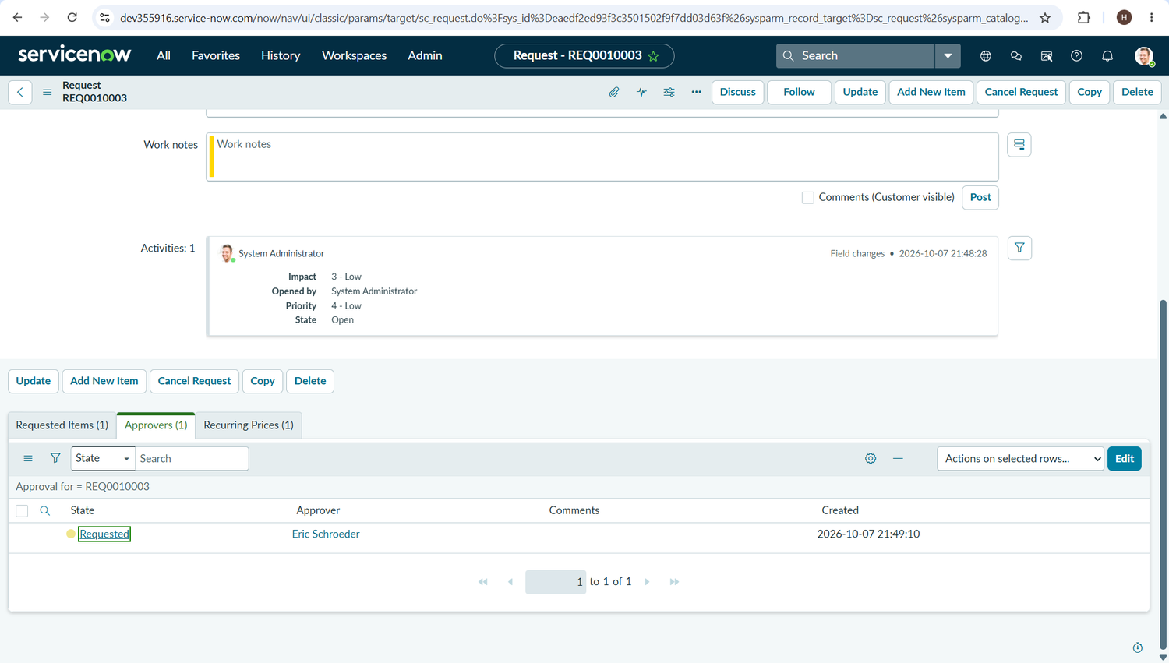
Figure 7.4: Approvers section of REQ0010003, approval in state Requested
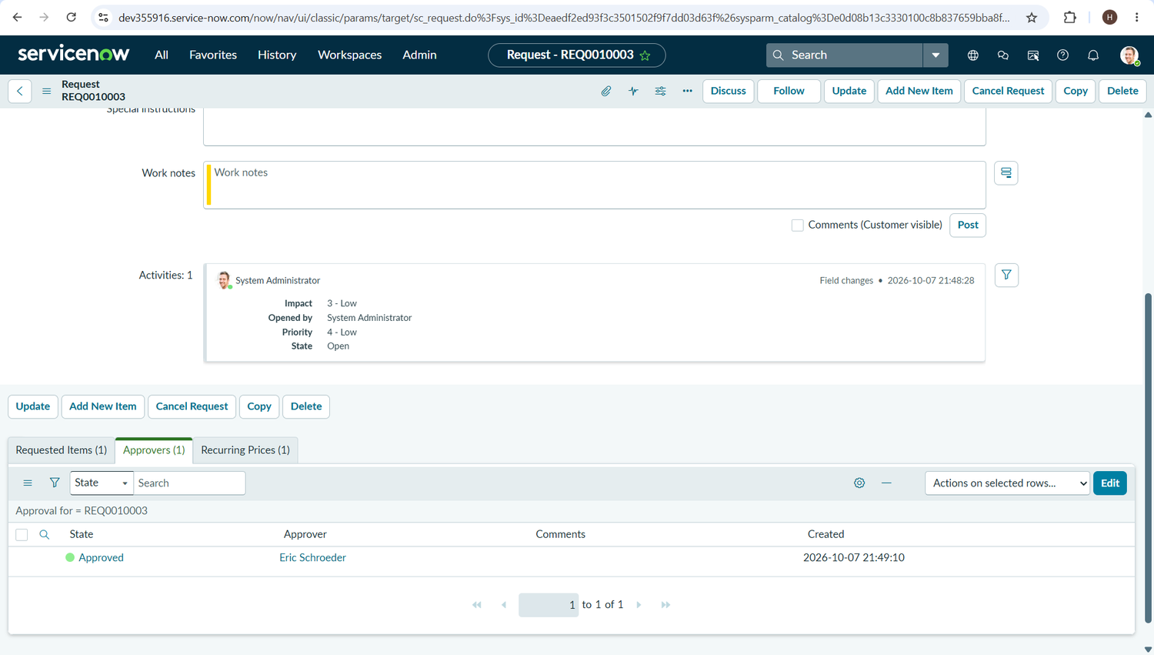
Figure 7.5: Approvers section of REQ0010003, approval in state Approved
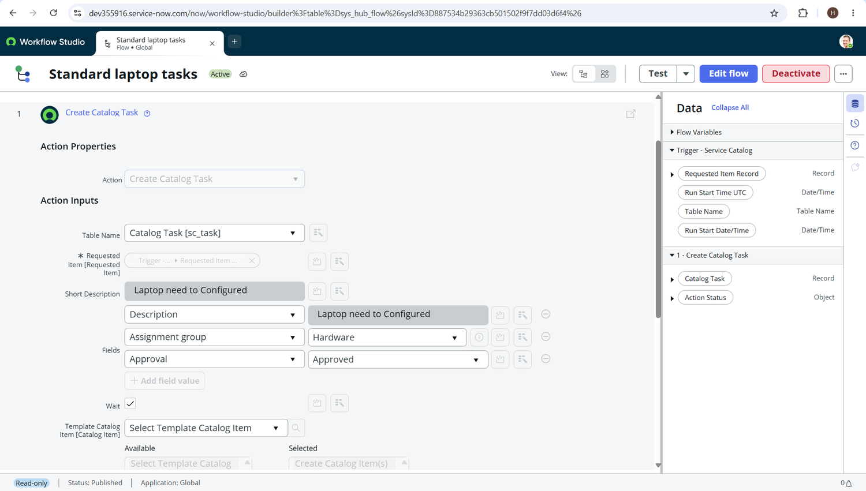
Figure 7.6: Flow "Standard laptop tasks" (Active) with the Create Catalog Task action and its field values
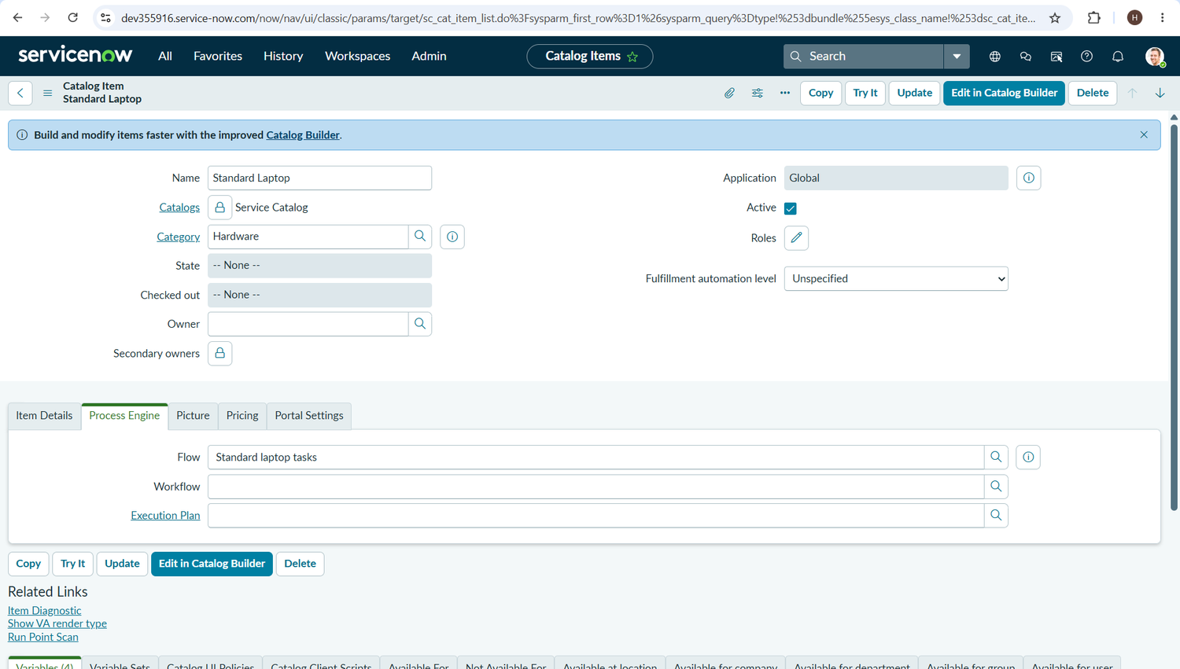
Figure 7.7: Standard Laptop catalog item > Process Engine tab, with the flow attached
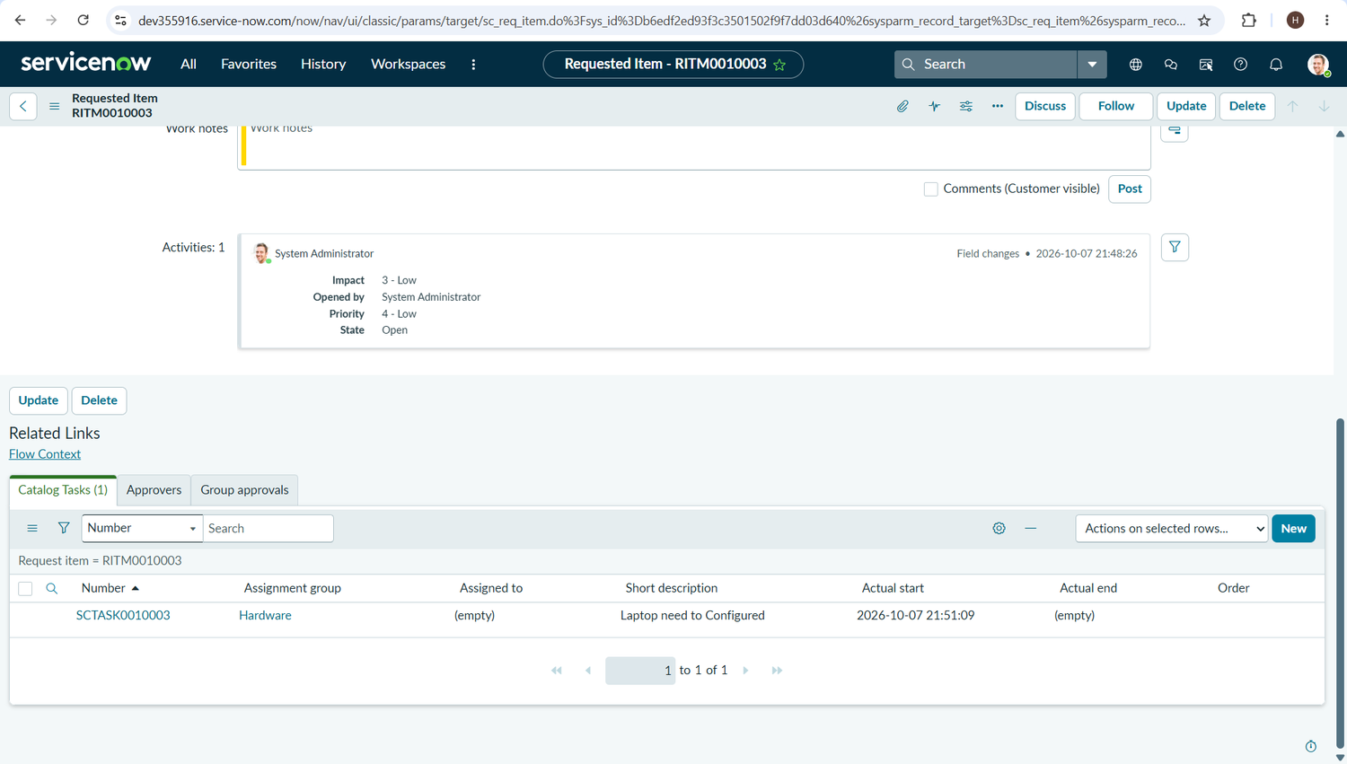
Figure 7.8: Requested Item RITM0010003 with the catalog task SCTASK0010003 assigned to Hardware
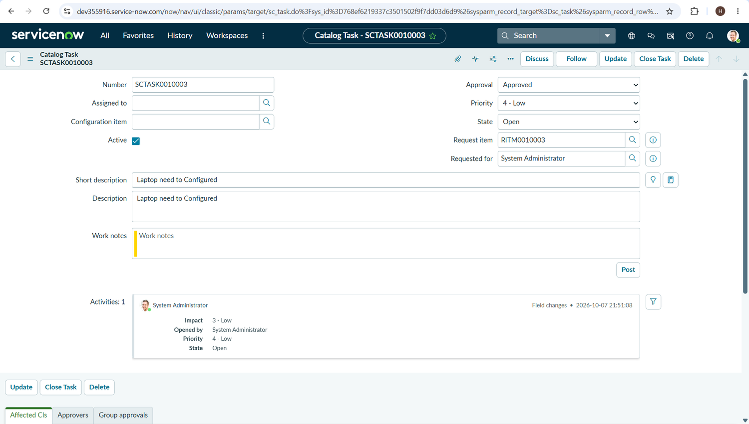
Figure 7.9: Catalog task SCTASK0010003 with short description, description and Approval set by the flow

8. ADVANTAGES & DISADVANTAGES
Advantages
- Configuration tasks are created automatically once a request is approved, so nobody has to remember to raise them.
- Tasks reach the Hardware group without manual assignment, which reduces delays and human error.
- Employees order through a single Standard Laptop catalog item and can follow the request through the Request Number, Requested Item and Catalog task records.
- One flow attached to the catalog item handles every standard laptop order, with no code changes needed as volume grows.
- The solution is low-code, runs on the managed ServiceNow cloud, and needs no extra infrastructure, external API or machine learning model.
- The Hardware team and IT procurement team spend less effort on manual task creation and follow-ups.
Disadvantages and limitations
- The solution covers standard laptops only; other hardware items need their own flow.
- Approval still depends on a person acting on the request, so the request waits until the approver responds.
- The task text is one fixed phrase ("Laptop need to Configured") and carries no requester or laptop details.
- The employee is not notified automatically; status is checked by opening the request records.
- The solution depends on the ServiceNow platform and on the Hardware team's availability to configure the laptop.
- Only one end-to-end run is recorded so far and no timing measurements exist, so the benefits above are expected outcomes until testing is complete.

9. CONCLUSION
The project addresses a specific gap in IT procurement: the manual, oversight-prone step between an approved standard laptop request and its configuration. By using ServiceNow Flow Designer, the team designed a flow that creates a catalog task from the Requested Item and assigns it to the Hardware group automatically after approval, attached to the Standard Laptop catalog item so that every order follows the same path.
The design, requirements, architecture and test cases are documented in this report. The expected benefits are fewer manual steps, fewer errors, prompt configuration on arrival and better use of IT resources. A first end-to-end run (request REQ0010003) shows the catalog task created and assigned to the Hardware group with the expected field values. The remaining benefits will be confirmed when the planned sprints and the rest of the UAT test cases are completed.

10. FUTURE SCOPE
The ideas that the team placed under future improvements during brainstorming, plus the extension noted in the proposed solution, define the future scope:
- Email the user when the laptop is ready.
- Escalate a catalog task automatically if it sits idle.
- Send a Slack alert to the Hardware team when a task is created.
- Add a dashboard for turnaround time, from approval to configuration.
- Auto-approve low-cost standard laptops.
- Auto-reorder laptops when stock is low.
- Reuse the same flow pattern for other standard hardware items.

11. APPENDIX
Source Code (if any)
The solution is a ServiceNow Flow Designer configuration with no hand-written source code. The flow and project documentation are in the GitHub repository below.
Dataset Link
Not applicable. The project uses no dataset.
GitHub & Project Demo Link
GitHub: https://github.com/Haresh-10/Streamlining-IT-Procurement-Automating-Standard-Laptop-Orders-with-Flow-Designer
Project demo: https://drive.google.com/file/d/1b9czpXHI1_tj0qGKukaTRUtzFrHFdK6o/view?usp=drivesdk

